**IO3.B –Community of Practice Admin Guideline**

The forum administration menu is accessible by clicking on "Administration" under the name of the logged in user, having the admin hierarchy.

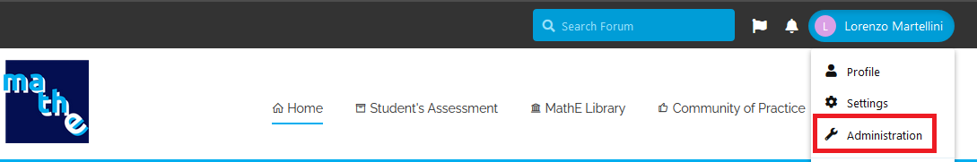

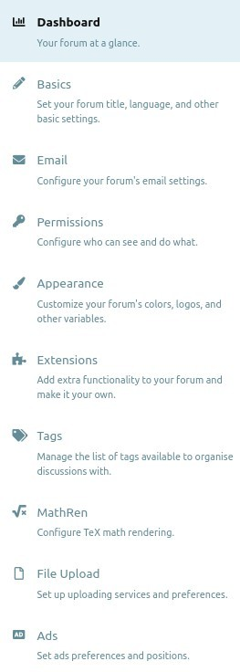

Periodic report of the results achieved by the forum: registrations, total discussions, etc ...

Here you can set the forum title, a description, a welcome banner and the first display of the homepage.

Here you can configure the sending mail server

Here you can assign various permissions to the various forum groups.

Here you can change the frontend graphics of the forum.

Here are the extensions (features) used by the forum.

Here it is possible to create and manage the various.

Here you can manage the KateX syntax, an extension of LateX.

Here you can manage the upload phase of the various files linked to the discussions.

Here you can insert HTML code that will be displayed in certain sections of the forum.